Avon City Council Meeting
December 4 2023
Mayor Kevin Tjeerdsma called the meeting to order at 7:00 p.m. with Alderman Muller. Berndt present; Alderman Dodge by phone answering roll call. Also, present finance officer Tina Gramkow, Police Officer Ted Smith, Brad Voigt, Jim Toupal; 7:10 Matt Tjeerdsma & Dennis Powers entered; 7:58 Joe Paulsen City Maintenance entered
All present recited the Pledge of Allegiance.
Moved by Muller second by Dodge to approve the agenda with additions of 4- way stop; pool update; wage increase for next year; lagoon maintenance & purchase of a leaf blower. All voting aye. Motion carried
Moved by Muller, second by Berndt to approve the minutes of November 6, 2023. All voting aye. Motion carried
Moved by Berndt, second by Dodge to approve the claims. All voting aye. Motion carried.
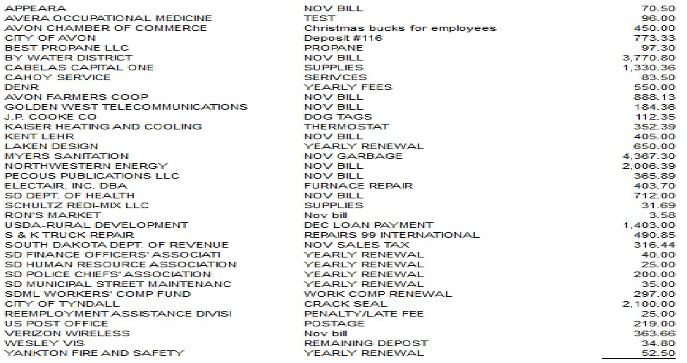Chamber of Commerce (Nov) Chamber drawing 25.00
November payroll: Mayor/council, $500.00; Library $1317.75; Finance Office $3059.00; Street Department $2055.52; Water Department $1878.32; Sewer Department $1878.32; Police $3377.00; SDRS, $1763.00; Health Pool of SD, $4,831.08; AFLAC, $262.58; Beam Dental/Vision, $303.67; IRS, $2524.03
Moved by Muller second by Dodge to approve the receipts. All voting aye. Motion carried.
Water sales $12516.20; Sewer sales $5095.80; Garbage receipts $5518.47; Ambulance $575.16; Building Permits $0; Property Tax $76723.32; Sales Tax $17064.45; 5% Motor Vehicle $552.44; Liquor License fee $1,000.00; Federal PILT, $391.33; other fees $406.00
Brad Voigt voice concerns of animals living in lumber building.
Matt Tjeerdsma asked about Abate Notices. Informed not picking on anyone as more than 1 notice was delivered. Further decision to be held in executive session.
Dennis Powers and Matt Tjeerdsma asked about zoom meetings. Informed council was not in favor at this time as there is a cost. Facebook Live was mentioned. FO will do further checking.
Committee reports:
Library: will be moving things around on Saturday December 9 & financial report given
Streets: crack sealing done
Recreation: pool filters to be installed
Dump: will be burning trees once get good snow fall & Schutz asked by dumping house that will he will be tearing down

OLD BUSINESS
Nuisance Property: Abatement Letters are being served
Awning tabled
Second Reading Cat Ordinance #354 Motion by Berndt Second by Dodge. All voting aye. Motion carried
Motion by Berndt, second by Muller to make changes to property insurance. All voting aye. Motion carried.
Motion by Dodge, seconded by Berndt to go with Light to Go Inc in amount of $2129.17 for flashing red light at 4- way stop on Main Street & Second Avenue. All voting aye. Motion carried.
NEW BUSINESS
8 Delinquent Notice Sent/4 door hanger with shut off
Police Officer Report given
Shop report given
Motion by Muller, seconded by Berndt to accept only bid for curb and gutter to Masonry Components. All voting aye. Motion carried
Motion by Muller, seconded by Berndt to allow bars to stay open December 31, 2023 until 2 am. All voting aye. Motion carried.
Sheriff’s contract was tabled until January meeting as council wants more information
Motion by Berndt, second by Dodge to give full time employees $100.00 Chamber buck and part time employee $50.00 chamber buck for the holidays. All voting aye. Motion carried.
Shop would like cameras at park is tabled until March or April.
City in in need of Lagoon Maintenance in spring, Joe is to get quotes.
Motion by Berndt, seconded by Dodge to purchase leaf blower to be used at City Office in winter and Shop in summer. All voting aye. Motion carried.

8:42 Motion by Berndt, second by Dodge to go into executive session.
9:41 Out of executive session.
Motion by Berndt, second by Dodge to increase salaries for January payroll as follows: Twila Lukkes $13.00; Joe Paulsen $19.30; Dan Knoll $17.91, Tina Gramkow $19.95. All voting aye. Motion carried.
Motion by Dodge, second by Muller to pay for pool filters once done so we can get grant paper work done. All voting aye. Motion carried.
Discussed Holiday Closure’s. City Finance Officer & City Shop will be closed Friday, December 22 & Monday, December 25, 2023, and January 1, 2024. Avon City Library will be closed Monday December 25, 2023 & January 1, 2024
Nuisance Property will send question to attorney. Waiting on response
Dated December 4 2023

Attest____________________________
Kevin Tjeerdsma, Mayor

Attest___________________________
Tina Gramkow, Finance Officer

ORDINANCE NO. 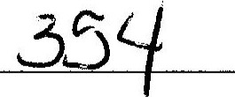
AN ORDINANCE ADOPTING REGULATIONS FOR CATS WITHIN THE MUNICIPALITY OF AVON, BON HOMME COUNTY, SOUTH DAKOTA.
BE IT ORDAINED BY THE MUNICIPALITY OF AVON, BON HOMME COUNTY, SOUTH DAKOTA AS FOLLOWS:

REGULATION OF CATS WITHIN CITY
l). General Definitions. Words when used in this Chapter unless the text otherwise plainly refers, shall have the meaning indicated:
- At Large. Off or outside of the premises belonging to the owner or keeper of such cat and not under the control of such owner or keeper, or the agent or servant member of his immediate family, by means of a leash, cord, rope or chain not to exceed ten (10) feet in length.
- Leash. A cord, rope, chain, device, or physical restraint not more than ten (10) feet in length by which a cat is controlled by the person accompanying it sufficient in nature to restrain cats.
- Owner. A person owning, keeping, or harboring a cat; the occupant of any premises to which a cat customarily returns is presumed to be the owner or person responsible for such cat.
- Domestic Cat. Any cat domesticated by humans so as to live and breed in a tame condition.
- Cat. Any member of the feline family, both male and female. For the purposes of this Ordinance, "cat" is meant to include only common domesticated cats, and not any wild species of cat.
- Premises. The dwelling house and outbuildings and the lot or tract of land on which the same are situated and shall include an automobile or other vehicle in which the owner of the cat shall be an occupant or of which he shall have control, or in which any cat shall be situated with the consent of the owner of the vehicle.
- Vaccination. The injection by a veterinarian or other qualified person of vaccine approved by, and administered in accordance with, the provisions of this Chapter and resolutions of the governing body of the City.
- Veterinarian. A licensed practitioner of veterinary medicine licensed to practice such profession in the state.
2). Limit in number of cats. It shall be unlawful for any person or persons, or household, within the City of Avon to have, keep, or possess more than three (3) adult cats. It is the intent of this Ordinance to set an aggregate limit to the number of cats that may be legally owned by one family, household, or co-habitants of any kind. The provisions of this paragraph shall not apply to litters of kittens from the time of their birth until they are six months old.
3). Cats at Large. It shall be unlawful for any cat within the City of Avon to run at large. An owner or keeper of any cat(s) within the City of Avon is deemed responsible for securing their cat(s) and preventing their cat(s) from running at large.
4). Prohibited Behavior. It shall be unlawful for any owner or keeper of a cat within the City of Avon, to permit their cat to engage in prohibited behavior. Prohibited behavior shall mean digging in garbage, destroying, or depositing bodily waste on shrubbery, lawns, flowers, or gardens.
5). Capture/lmpoundment of Cats in violation. The person designated by the City Council as the City Animal Control Officer is hereby authorized to employ reasonable methods, whenever he/she may deem it necessary, to capture, seize and impound any cats running at large or engaging in prohibited behavior contrary to the provisions of this chapter. It shall be the duty of the designated City Animal Control Officer to live-trap and humanely remove any domesticated cats running at large or engaging in prohibited behavior. Any non-domesticated or feral cats may be trapped and impounded at the discretion of the City Animal Control Officer and after reasonable period of time, such non-domesticated or feral cats may be euthanized and properly buried.
6.) Rabies or Hydrophobia. Any person who shall suspect that any cat in the City is infected with rabies or hydrophobia shall report his/her suspicion to the local police or health authorities, describing the cat and giving the name of the owner, if known. If upon examination of health authorities, the cat shall prove in fact to be infected with said disease, the cat may be euthanized by the person designated as the City Animal Control Officer.
Should any disease be found prevalent among cats in the City or should any condition of such disease warrant, the City Mayor may in the interest of the general welfare, order, by proclamation, the impound and examination of all cats until the same condition is arrested, taking such measures as may, in the interest of the general welfare, be necessary to arrest the disease.
7). Penalty. Any person in violation of this Ordinance shall be deemed guilty of a misdemeanor, and upon conviction thereof, shall be fined in a minimum amount of twenty-five dollars ($25.00) plus costs, and each subsequent violation in the same year shall result in a minimum increase in the fine by twenty-five dollars ($25.00) per subsequent violation (i.e., twenty-five dollars ($25.00) for first offense, fifty dollars ($50.00) for second offense, seventy-five dollars ($75.00) for third offense, etc., plus costs, up to a maximum fine of five hundred ($500.00) dollars). Each day a violation continues shall be considered a separate offense.

Dated this 4th day of December, 2023.
____________________________________
Mayor

First Reading: 10/2/2023
Second Reading: 12/4/2023
Passed and Approved: 12/4/2023
Published: 12/13/2023

